How to schedule a Cron job ?

Objective :

To invoke a specific end point that performs certain task in a certain timings then we can go for scheduled jobs/cron jobs.

Cron jobs are scheduled at Kubernetes and can be triggered regularly in a particular time.

Procedure to setup Cron job:

There are 2 different classification of setup needed for scheduling the Cron job

1. Setup done in ccpay-schduled-jobs
2. Setup done in ccpay-flux-config
3. Setup fone in ccpay-schdule-jobs:

Step 0: Clone the repo : <https://github.com/hmcts/ccpay-scheduled-jobs.git>

## Step1: Create the java class in the folder

src/main/java/uk/gov/hmcts/payment/processors/DeadLetterQueueProcessor.java

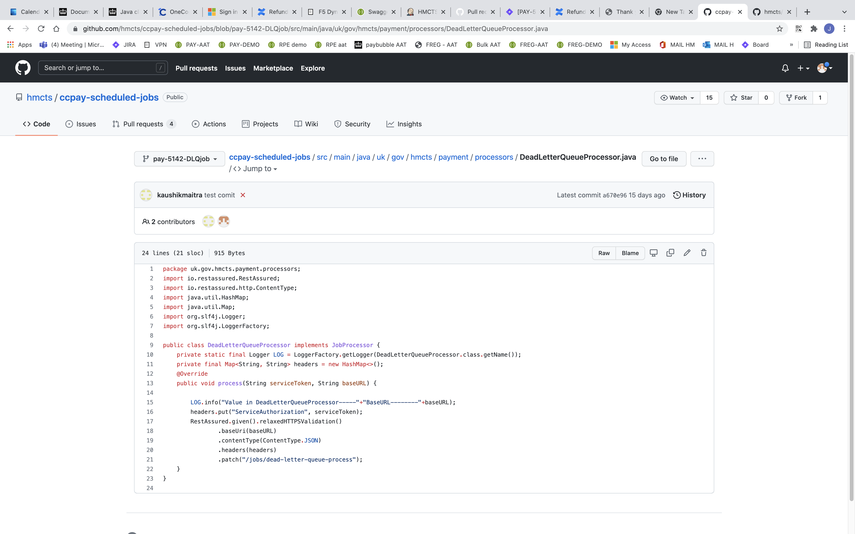

Make changes : Line 9 (name of the class) , Line 10: (class name) , Line 15 (comment) , Line 21 (end point)

Step2 : Create the test case : src/test/java/uk/gov/hmcts/payment/processors/DeadLetterQueueProcessorTest.java

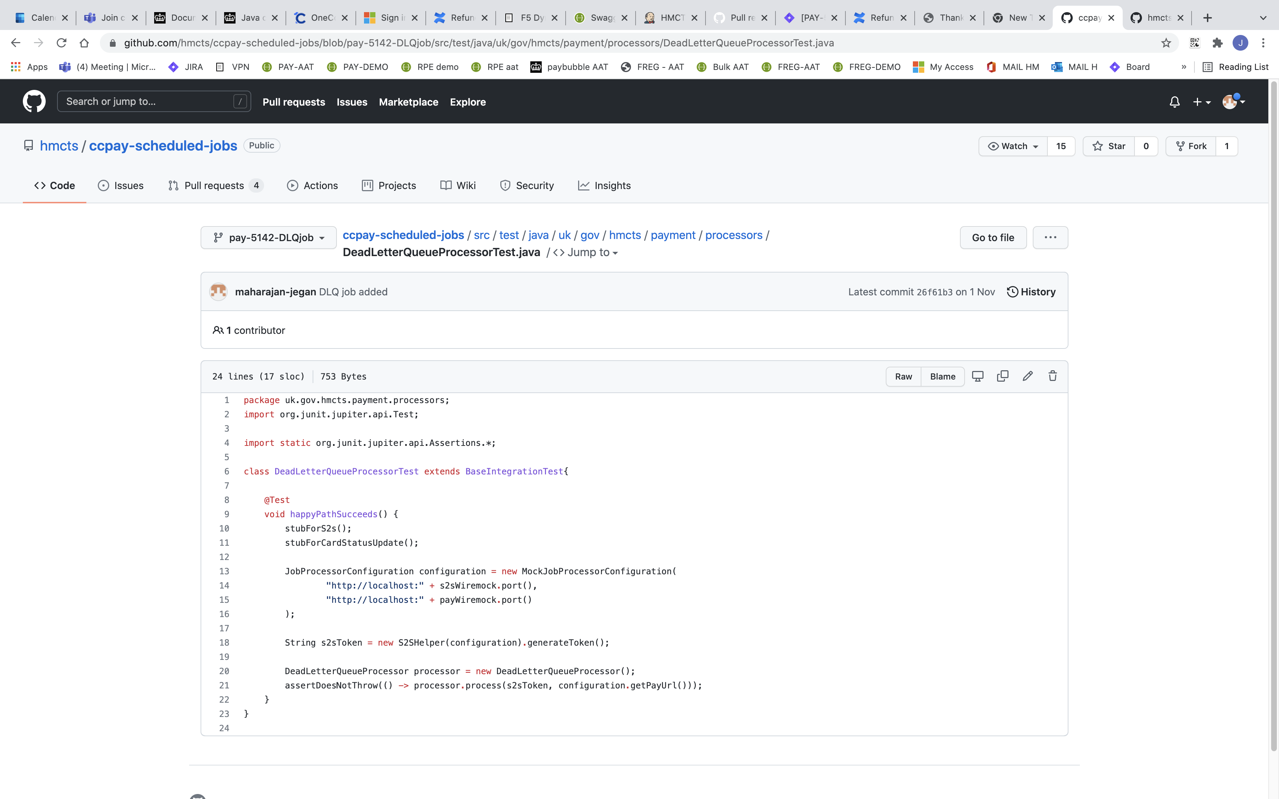

Step 3: add a cnp_flux-config trigger keyword

src/main/java/uk/gov/hmcts/payment/processors/JobProcessorFactory.java

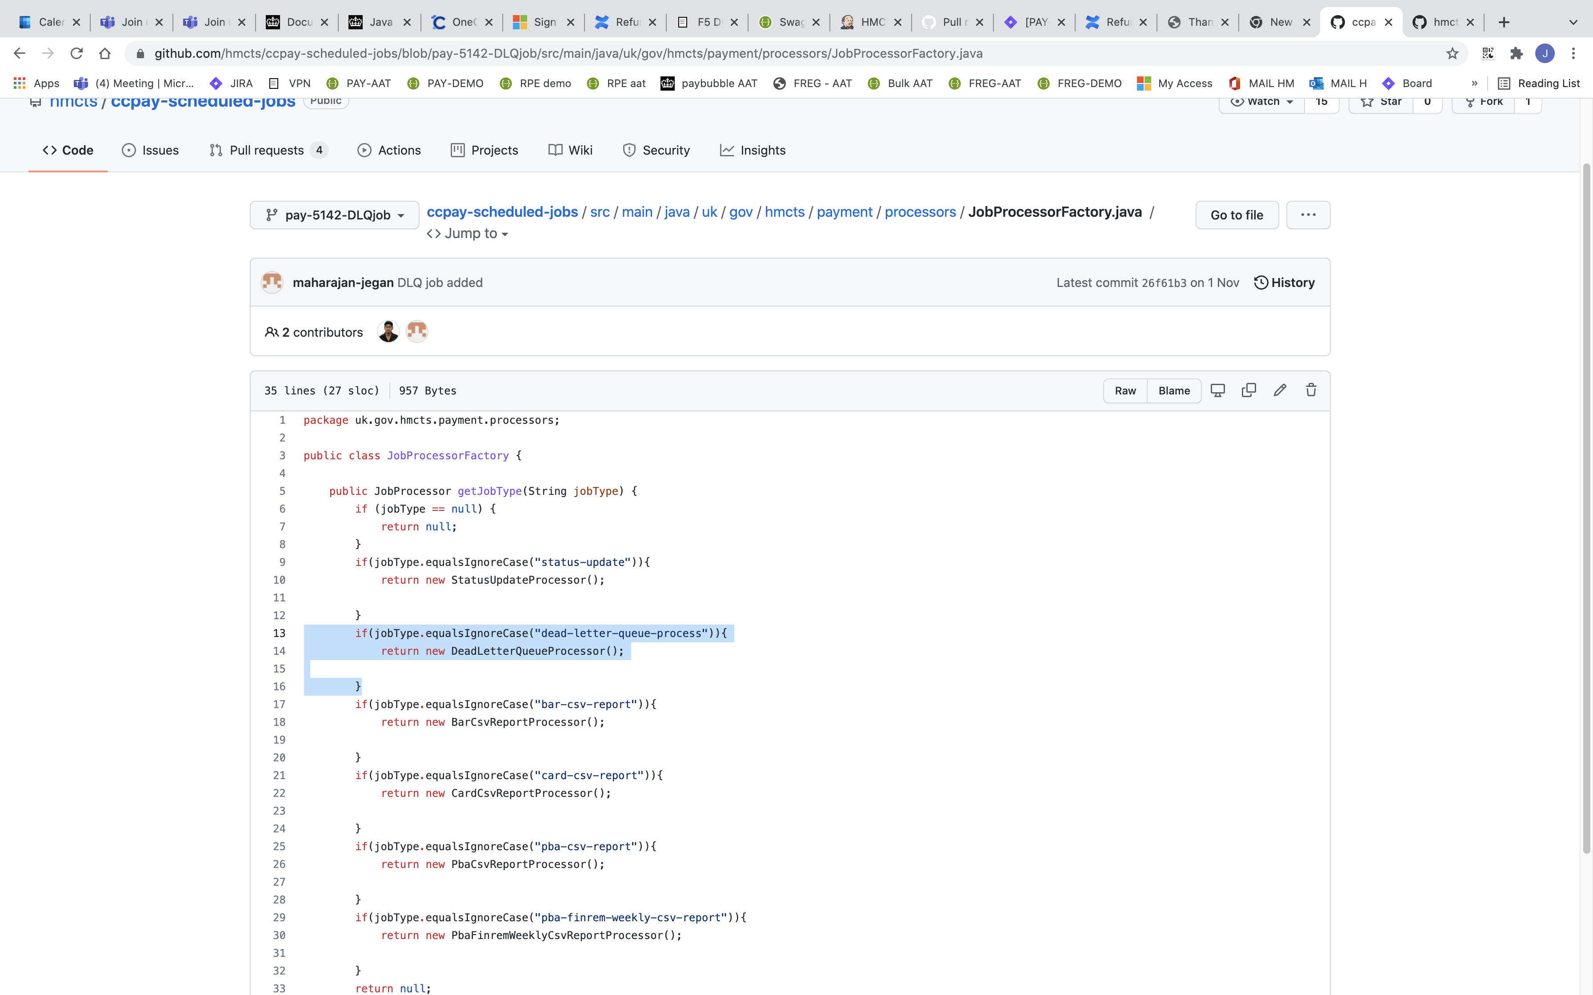

Step 4 : create a PR and deploy it in demo

b. Setup done in ccpay-flux-config

step 1: create the policy files in apps/fees-pay with your service name (eg . dead-letter-queue-procexx folder)

* demo-image-policy.yaml
* image-policy.yaml
* image-repo.yaml

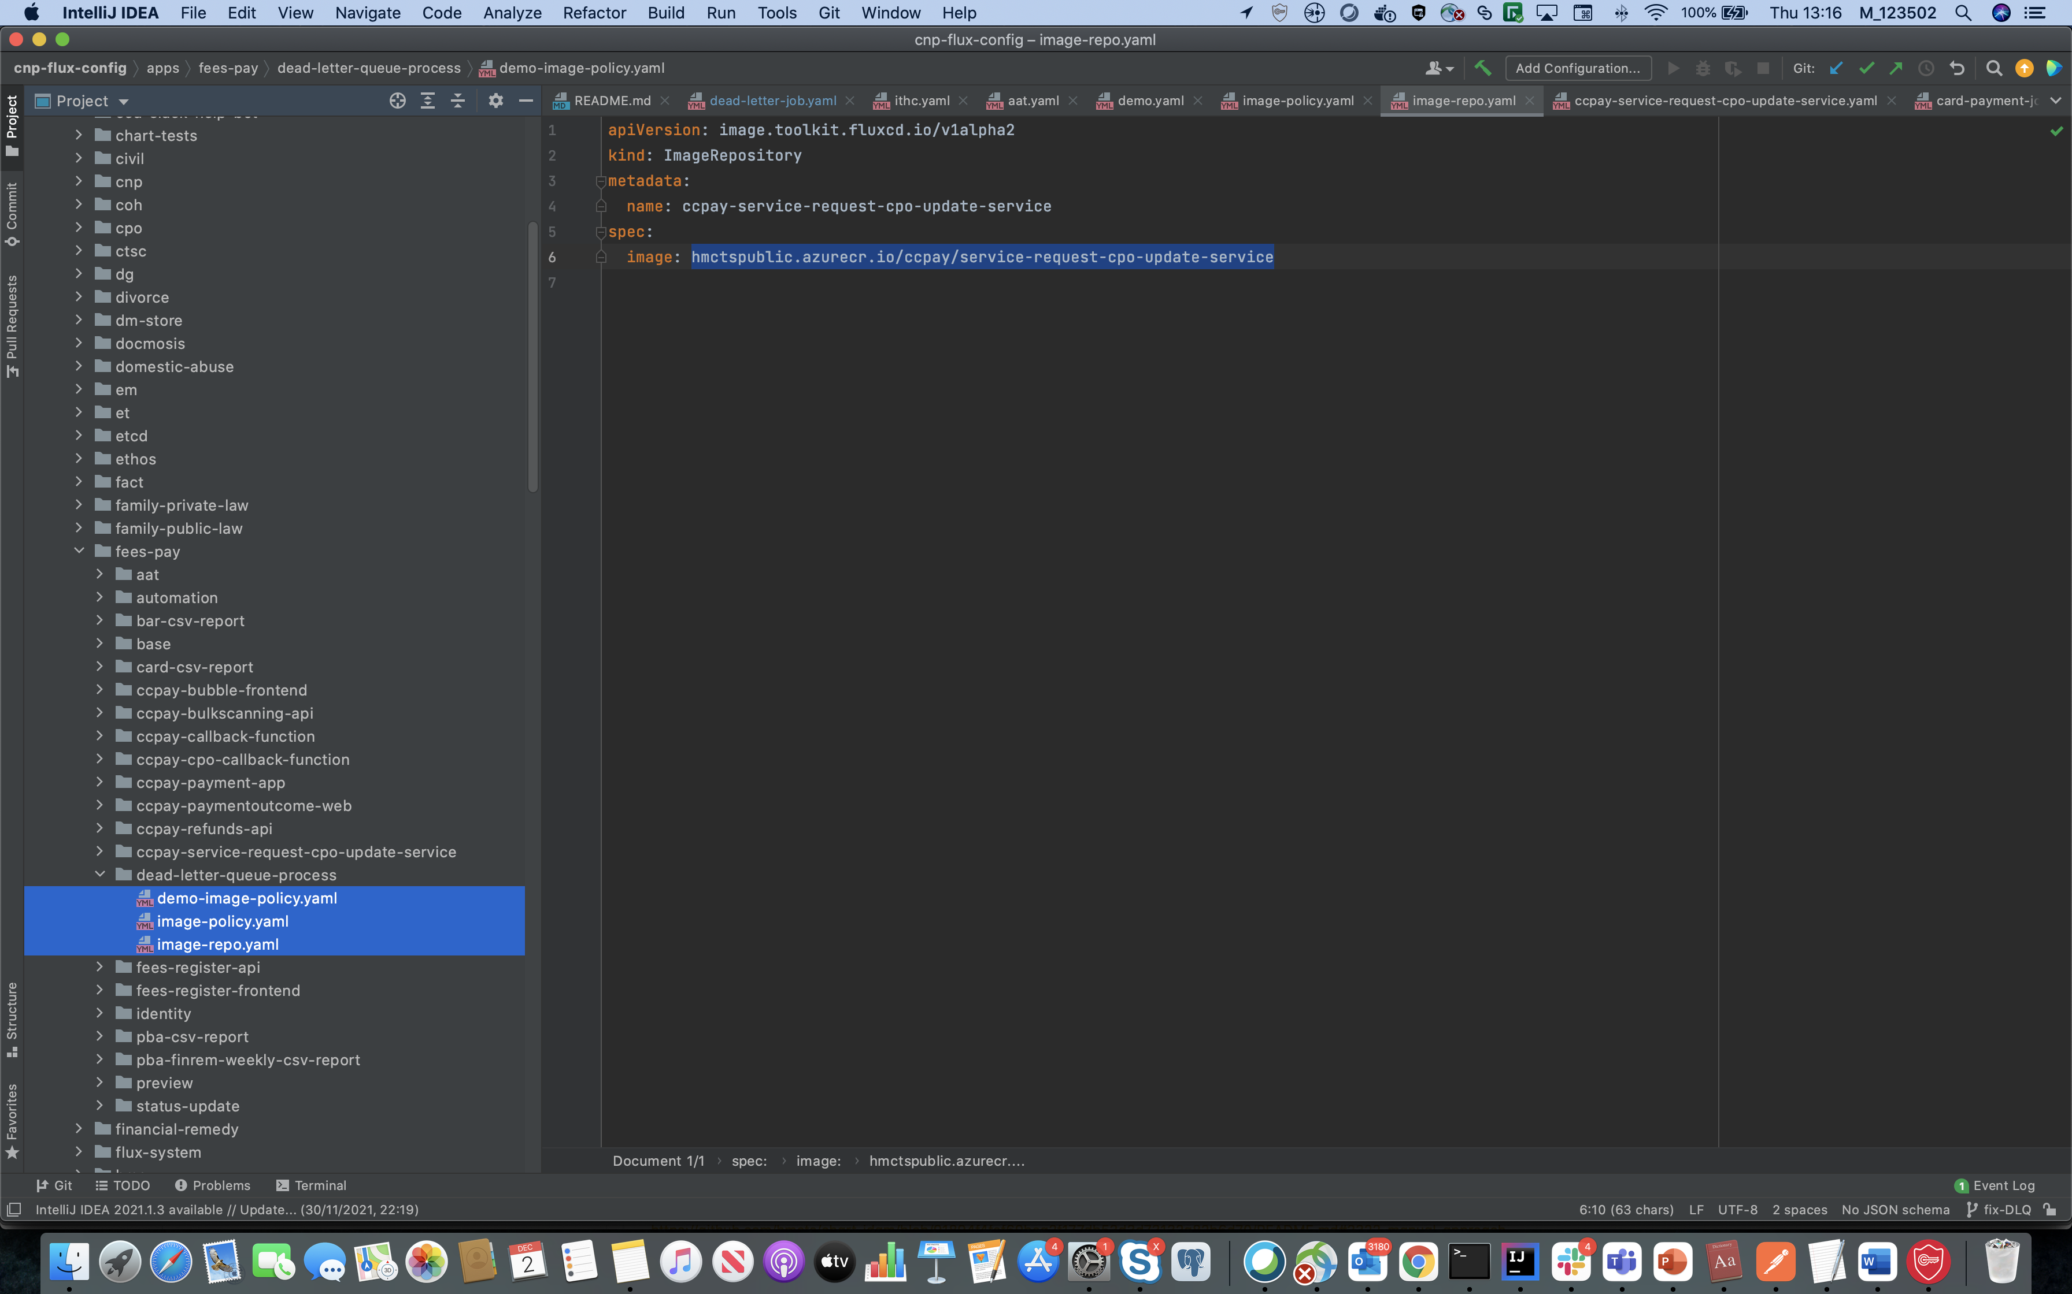

Step 2: in Demo-image-policy.yaml file add your PR number of ccpay-scheduled-jobs

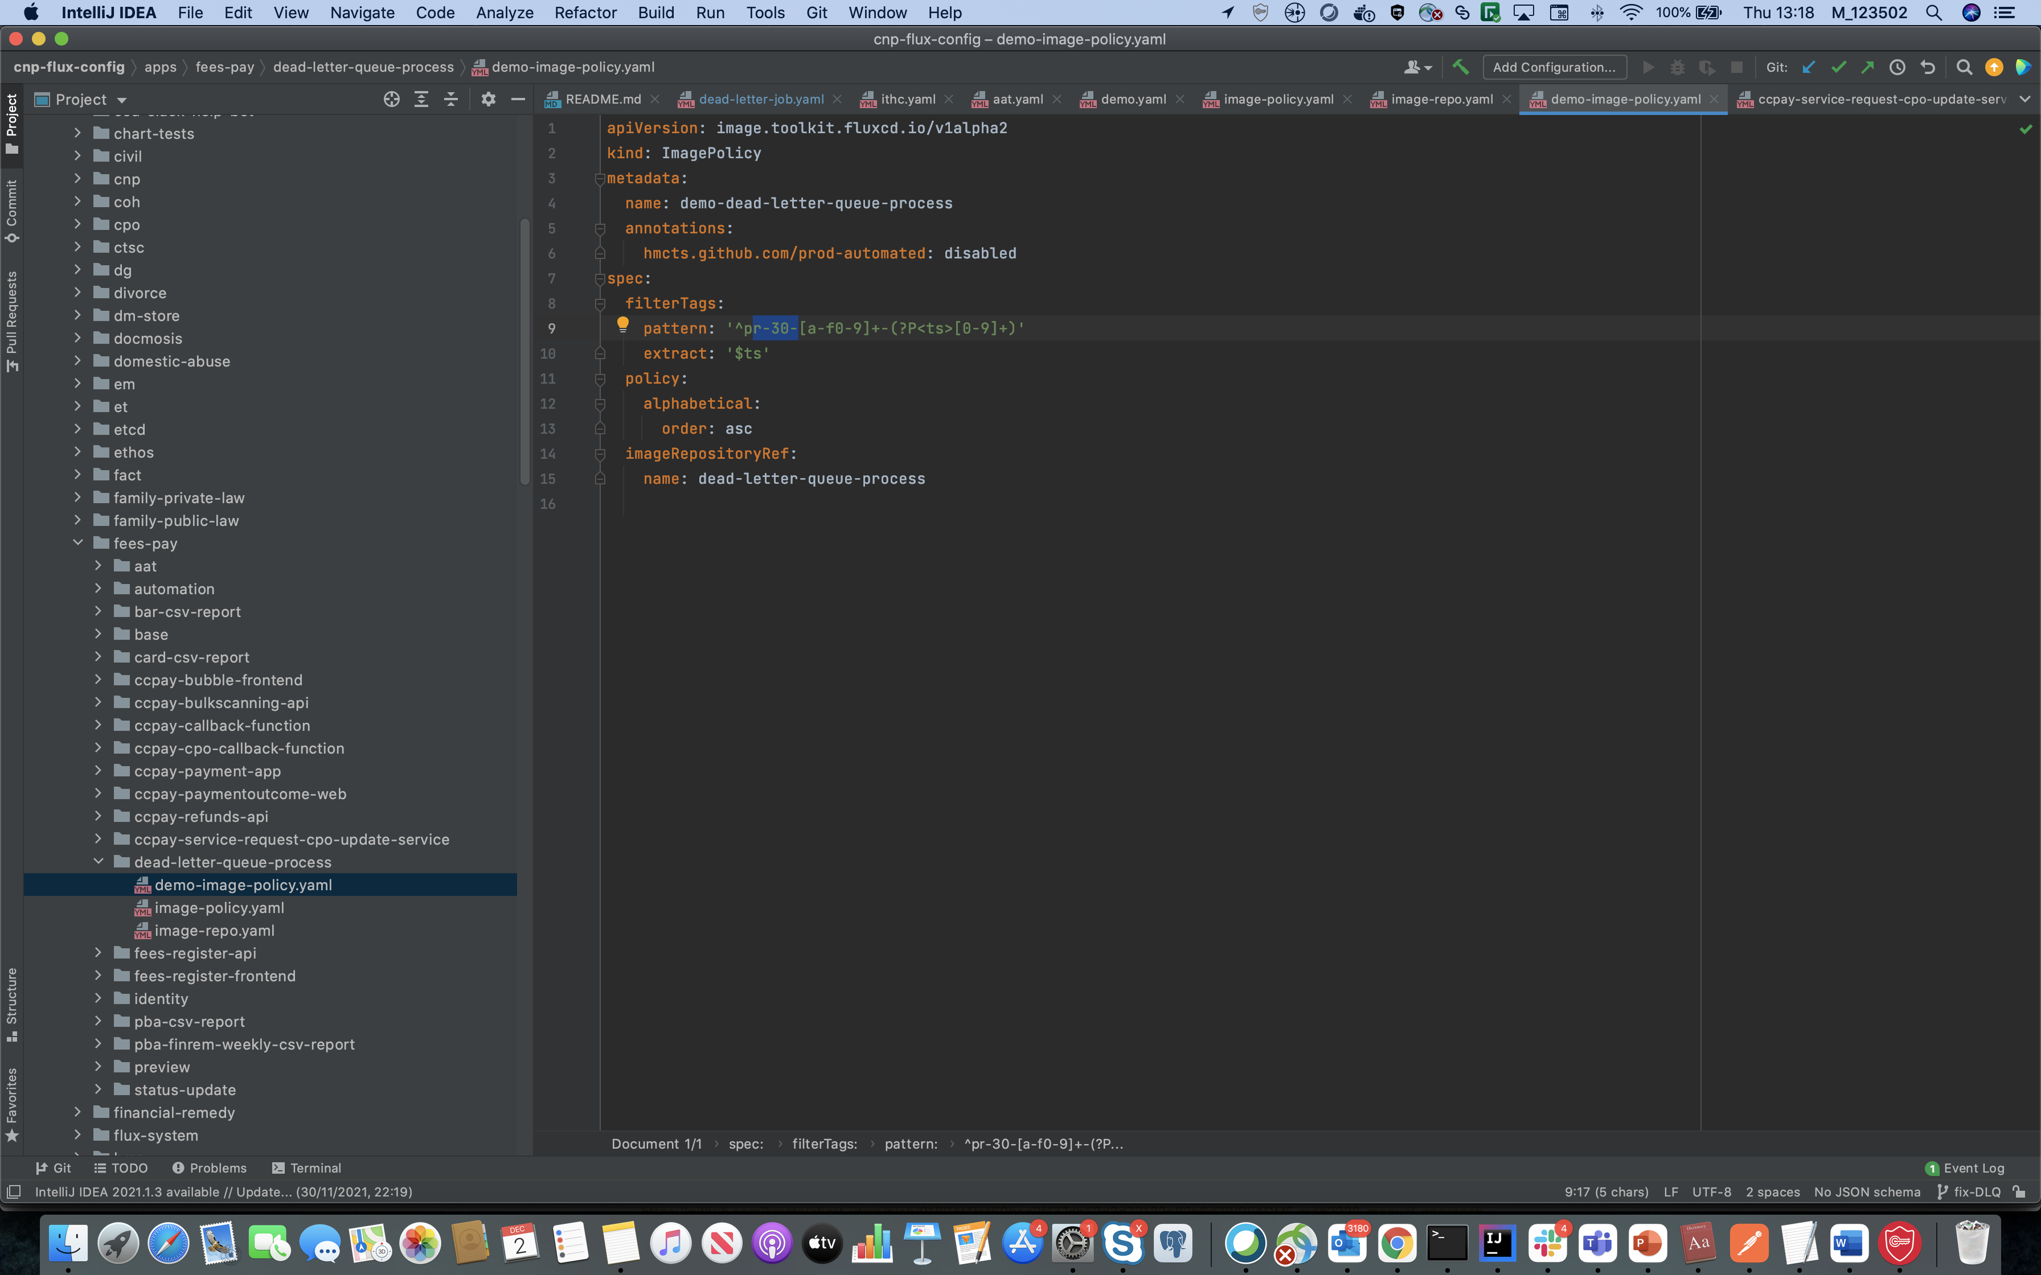

Image-policy.yaml file just mention your service name

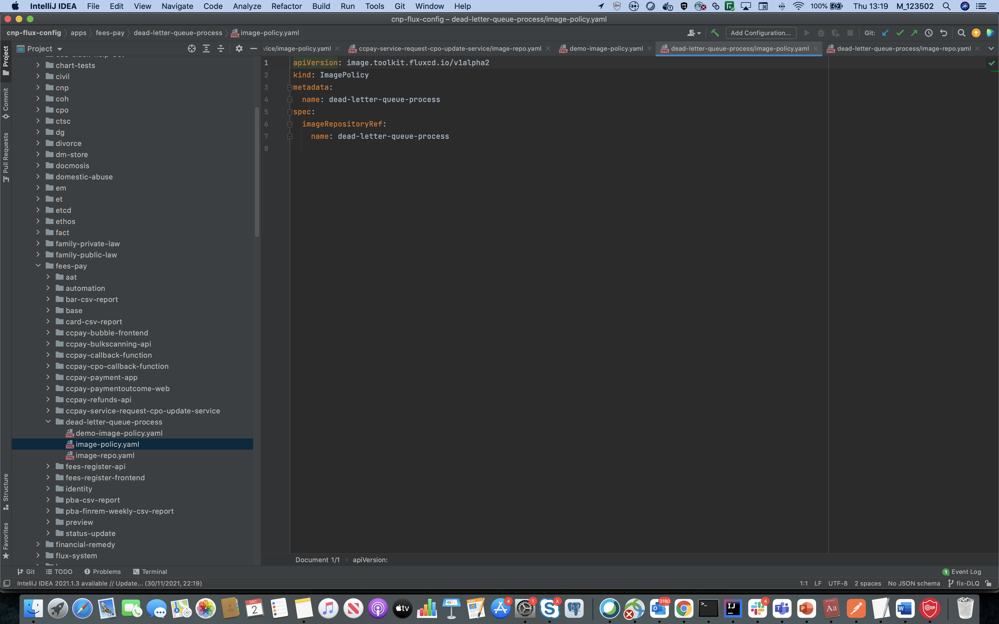

Image-repo.yaml file just mention your service name and image name

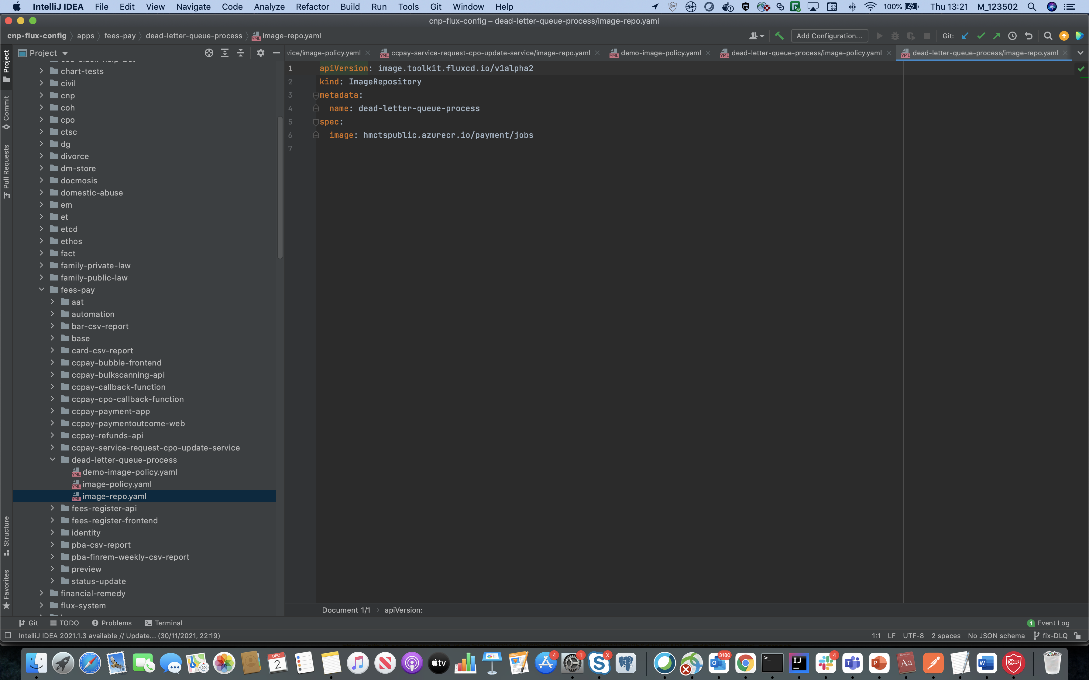

Step 2:

Create your serice yaml file in

K8s/demo/cluster-01/fees-pay/{create file for your service}

* mention image name
* mention schedule
* mention service name

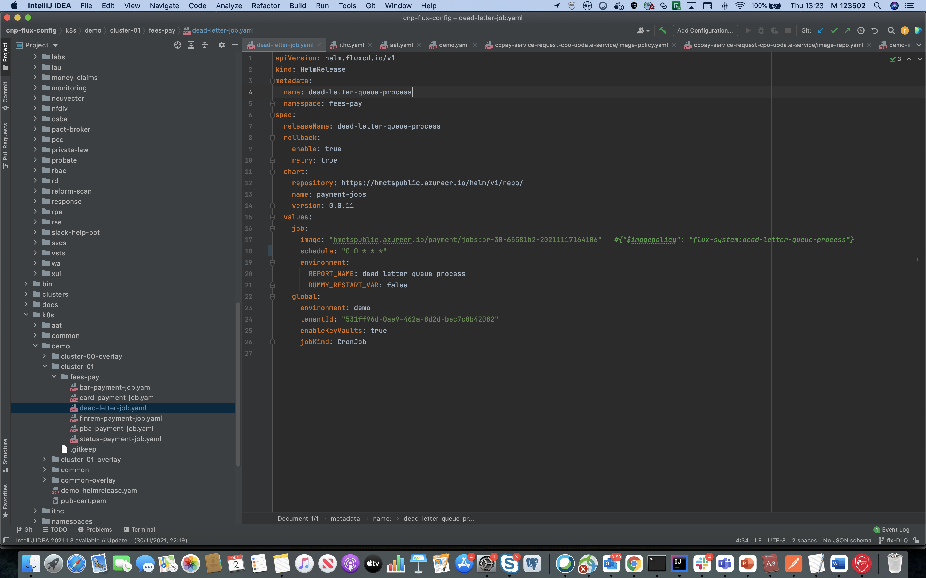

Merge the ccpay-flux-config with master then verify the POD using

Kubectl get pods -n fees-pay

Kubectl describe pod {pod name} -n fees-pay

Kubectl logs {pod name} -n fees-pay